**Lab 11**

**Done by 21k-3881**

* **Create database**

**Command: use myfistdb**

**Command: show dbs**

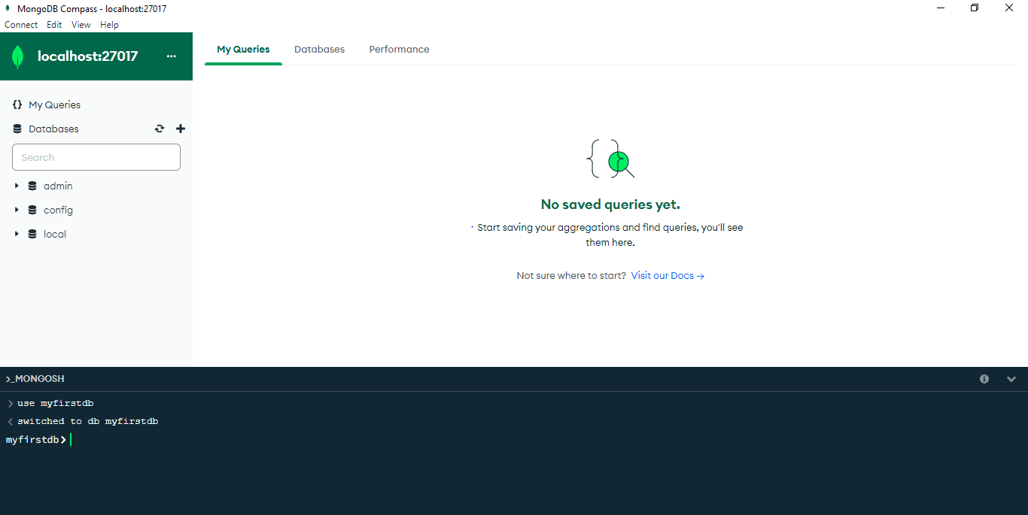

* **Create table in database**

**Command: db.createCollection(“restaurants”)**

**Command: show collections**

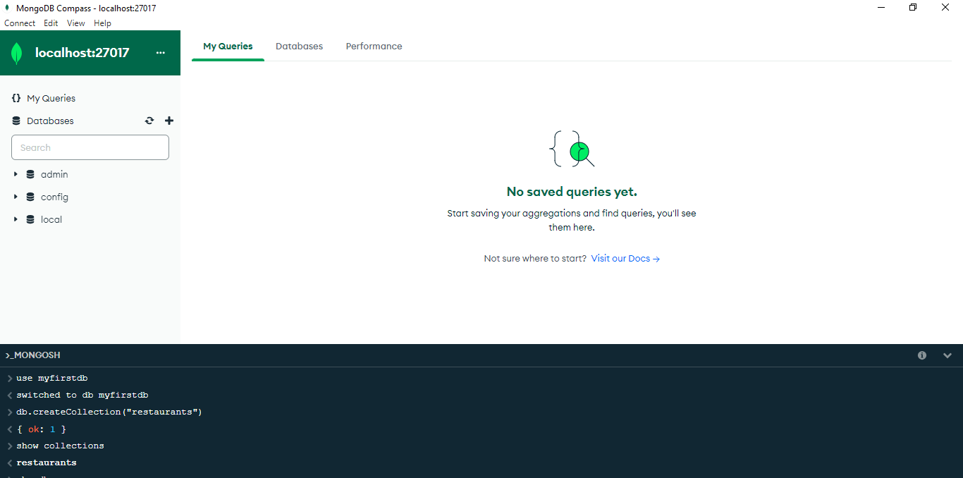

* **Insert data**

**Command:**

**db.restaurants.insert(**

**{**

**"address": {**

**"building": "1007",**

**"coord": [ -73.856077, 40.848447 ],**

**"street": "Morris Park Ave",**

**"zipcode": "10462"**

**},**

**"borough": "Bronx",**

**"cuisine": "Bakery",**

**"grades": [**

**{ "date": { "$date": 1393804800000 }, "grade": "A", "score": 2 },**

**{ "date": { "$date": 1378857600000 }, "grade": "A", "score": 6 },**

**{ "date": { "$date": 1358985600000 }, "grade": "A", "score": 10 },**

**{ "date": { "$date": 1322006400000 }, "grade": "A", "score": 9 },**

**{ "date": { "$date": 1299715200000 }, "grade": "B", "score": 14 }**

**],**

**"name": "Morris Park Bake Shop",**

**"restaurant_id": "30075445"**

**});** 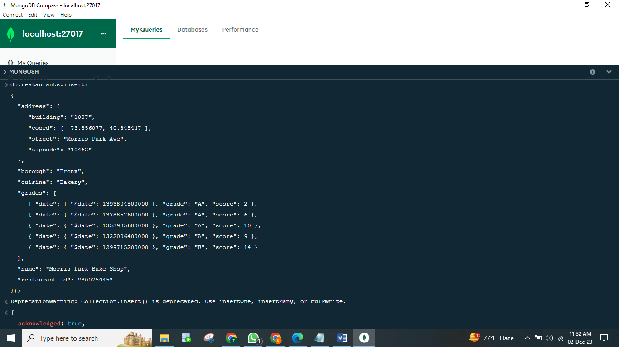

**Task_01:**

**Command: db.restaurants.find();**

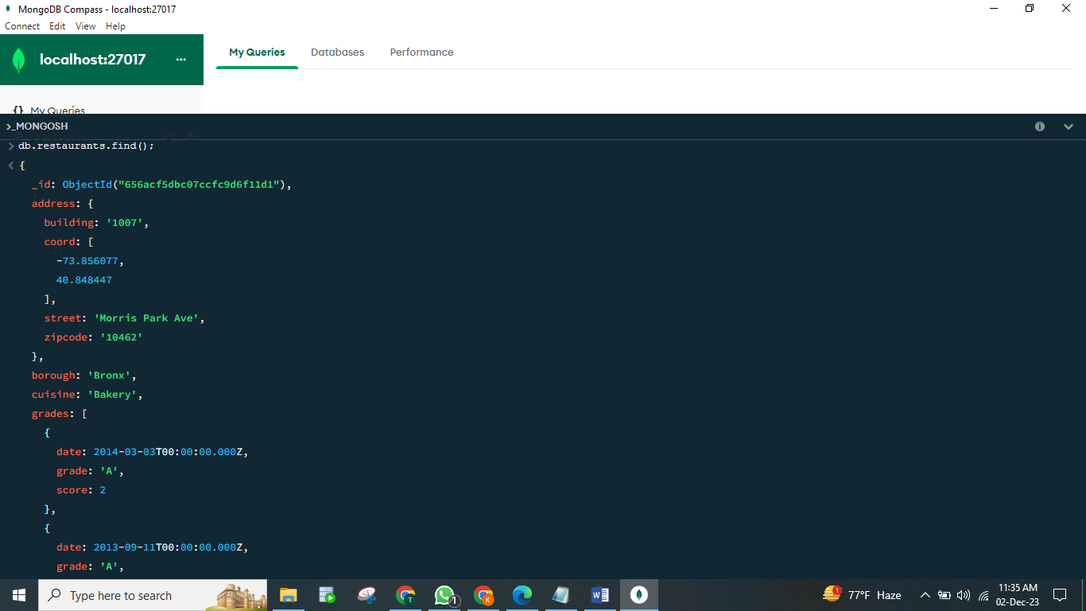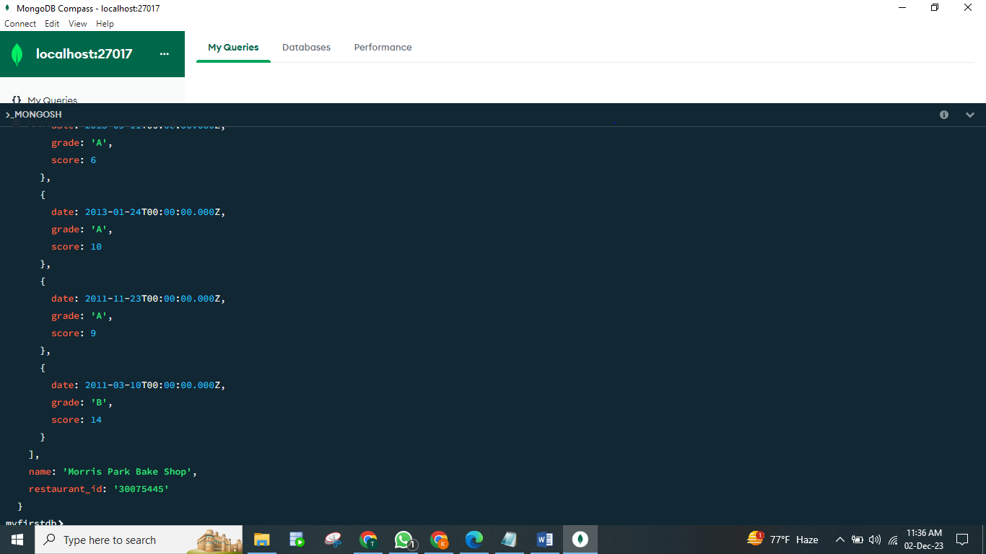

**Task_02 and Task_03:**

**Task02 Command: db.restaurants.find({},{"restaurant_id" : 1,"name":1,"borough":1,"cuisine" :1});**

**Task03 Command: db.restaurants.find({},{"restaurant_id" : 1,"name":1,"borough":1,"cuisine" :1, "_id":0});**

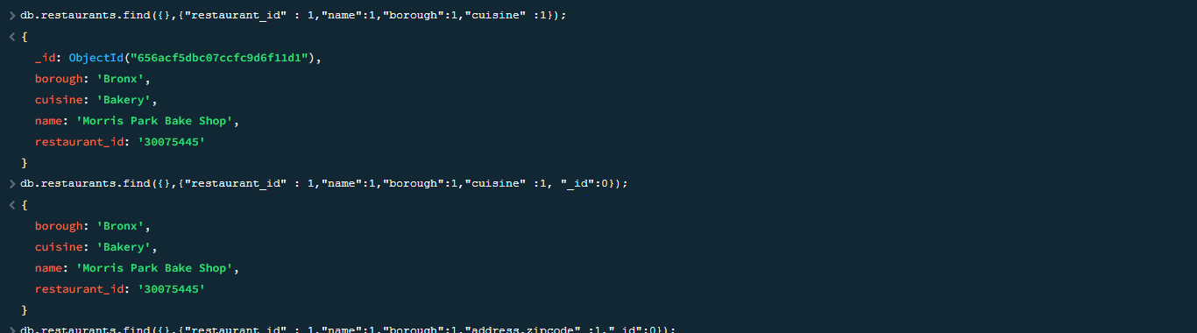

**Task_04:**

**Command: db.restaurants.find({},{"restaurant_id" : 1,"name":1,"borough":1,"address.zipcode" :1,"_id":0});**

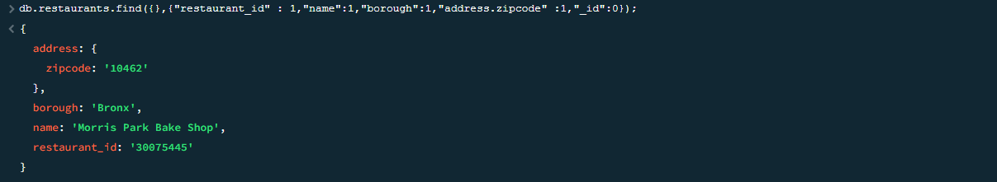

**Task_05:**

**Command: db.restaurants.find({"borough": "Bronx"});**

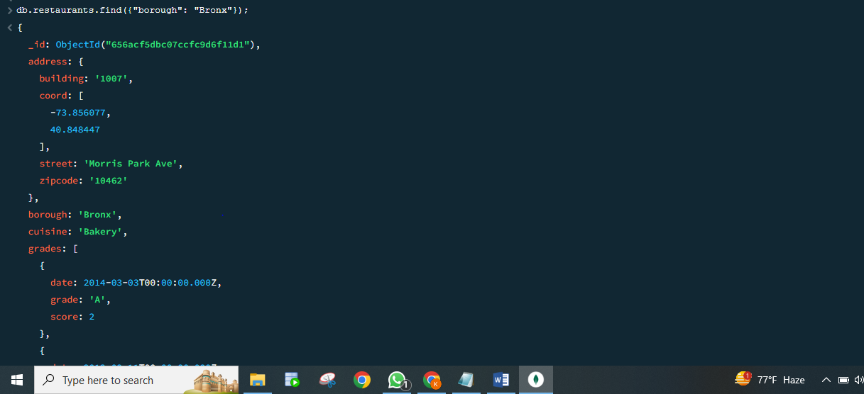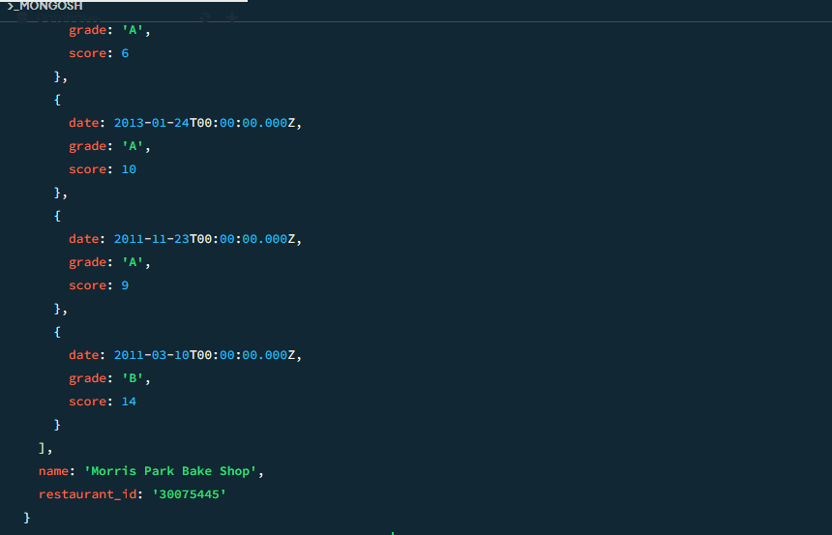

**Task_06:**

**Command: db.restaurants.find({"borough": "Bronx"}).limit(5);**

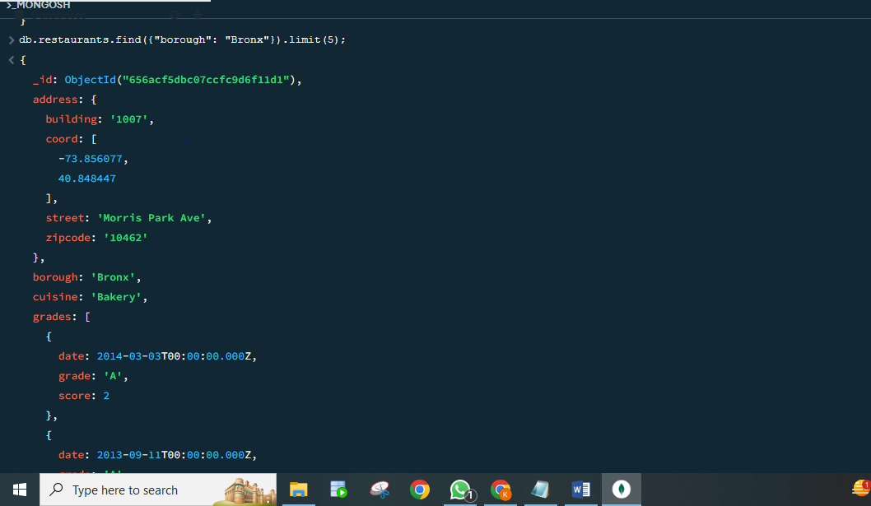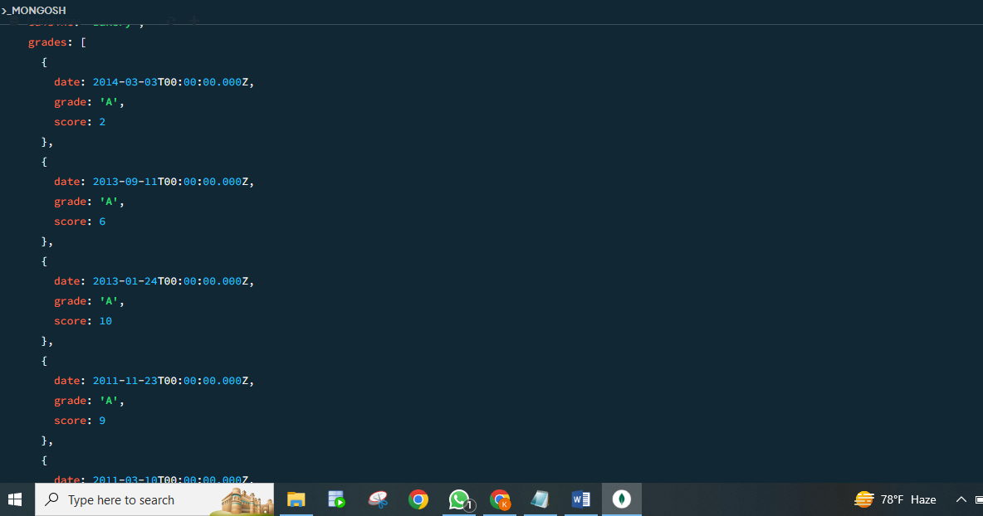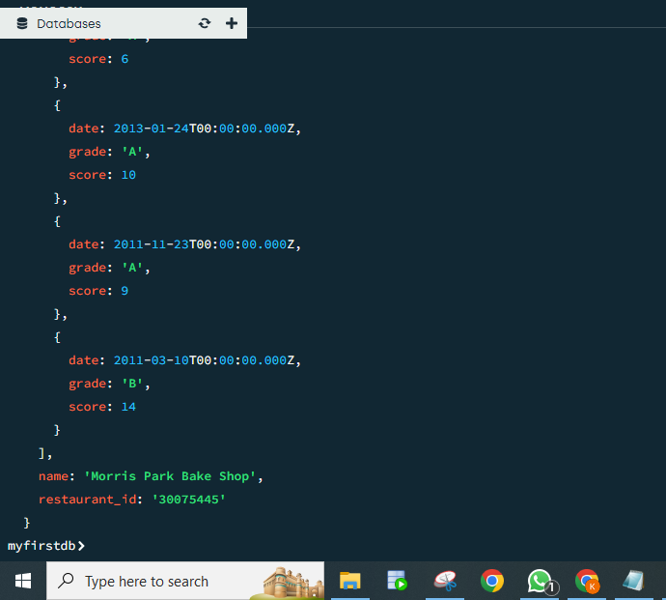

**Task_07:**

**Command: db.restaurants.find({"grades": { "$elemMatch": {"score": { "$gt": 90 } }}});**

**Task_08:**

**Command: db.restaurants.find({grades : { $elemMatch:{"score":{$gt : 80 , $lt :100}}}});**

**Task_09:**

**Command: db.restaurants.find({"address.coord" : {$lt : -95.754168}});**

**Task_10:**

**Command: db.restaurants.find({"borough": "Bronx" , $or : [ { "cuisine" : "American " }, { "cuisine" : "Chinese" }]});**

* **Screen shot of task7-10:**

